**Day 4:**

LinkedList : LinkedList is another type of linear data structure which internally use **node** concept to store data.

Node hold the data of any type as well as reference of another node object.

Depending upon type of linked list node can hold value or data of any types as well as one or more than one another node object or reference.

Types of linked list

1. Single linked list
2. Double linked list
3. Circular single linked list
4. Circular double linked list

**Single linked list**

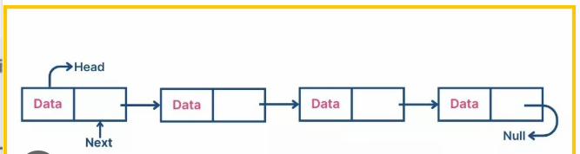

**Double linked list**

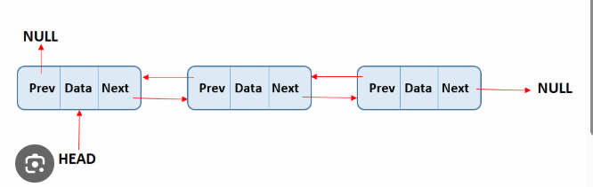

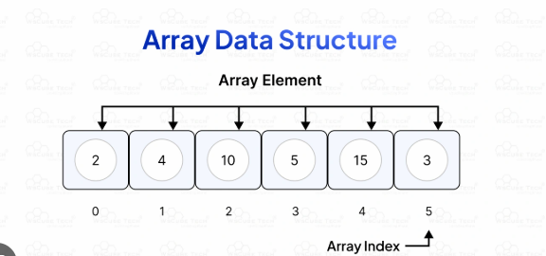

**Non linear data structure**

Tree : Tree is non linear data structure which use node concept to hold the data.

A tree is a made up with node and it start from top to bottom it connect like hierarchical manner.

Each node can have zero or more childe nodes

The node that don’t have any children they are called leaf node.

A -🡪 Root node or parent node

B C -🡪 children node

D E F Gchildren node (leaf node)

A -🡪 root node

A,B and C 🡪 parent node (which have 1 or more children)

D,E,F,G 🡪 leaf node

Edge -🡪 Connection between one node to another node

Sub tree 🡪 B 🡪 D and E

To retrieve the information from Tree structure we use two technique

1. DFS -> Depth – first search
2. BSF -> Breath first search

Graph : A graph is a non-linear structure use to represents relationship between two object or nodes.

Graph consists of

1. Vertices (node)
2. Edge (links or connection)